Dictionary Lexicon

What is Dictionary Lexicon
# Source: AI Source: Provided by: [Data Path: Persons Table -> ID Column: 1, Name_En Column: Motasem Essam] -> From: [Chatgpt (GPT-4-turbo)] on [7/29/2025]
A Dictionary Lexicon refers to a standardized and curated collection of words and their meanings, typically arranged alphabetically, and found in published dictionaries—both print and digital. It is designed to provide comprehensive definitions, pronunciation, usage, etymology, and other linguistic information.

🔹 Key Features of a Dictionary Lexicon
# Source: AI Source: Provided by: [Data Path: Persons Table -> ID Column: 1, Name_En Column: Motasem Essam] -> From: [Chatgpt (GPT-4-turbo)] on [7/29/2025]
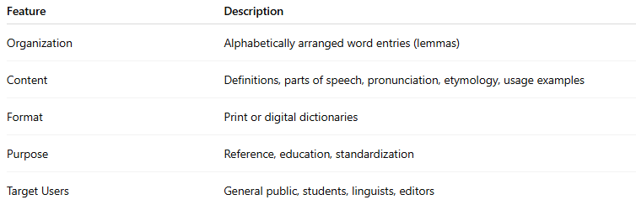
Feature | Description
Organization | Alphabetically arranged word entries (lemmas)
Content | Definitions, parts of speech, pronunciation, etymology, usage examples
Format | Print or digital dictionaries
Purpose | Reference, education, standardization
Target Users | General public, students, linguists, editors

🔹 What It Includes
# Source: AI Source: Provided by: [Data Path: Persons Table -> ID Column: 1, Name_En Column: Motasem Essam] -> From: [Chatgpt (GPT-4-turbo)] on [7/29/2025]
- Lemmas: Main dictionary entries (e.g., run, happy, teach)
- Definitions: Clear and concise meanings of each word
- Grammatical info: Part of speech, countability, transitivity
- Pronunciation: Phonetic transcription (IPA)
- Etymology: Word origin and history
- Usage examples: Sentences showing real-world application
- Synonyms/Antonyms (in many dictionaries)

🔹 Examples of Dictionary Lexicons
# Source: AI Source: Provided by: [Data Path: Persons Table -> ID Column: 1, Name_En Column: Motasem Essam] -> From: [Chatgpt (GPT-4-turbo)] on [7/29/2025]
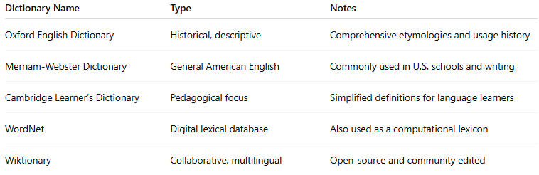
Dictionary Name | Type | Notes
Oxford English Dictionary | Historical, descriptive | Comprehensive etymologies and usage history
Merriam-Webster Dictionary | General American English | Commonly used in U.S. schools and writing
Cambridge Learner’s Dictionary | Pedagogical focus | Simplified definitions for language learners
WordNet | Digital lexical database | Also used as a computational lexicon
Wiktionary | Collaborative, multilingual | Open-source and community edited

🔹 Dictionary Lexicon vs Other Lexicons
# Source: AI Source: Provided by: [Data Path: Persons Table -> ID Column: 1, Name_En Column: Motasem Essam] -> From: [Chatgpt (GPT-4-turbo)] on [7/29/2025]
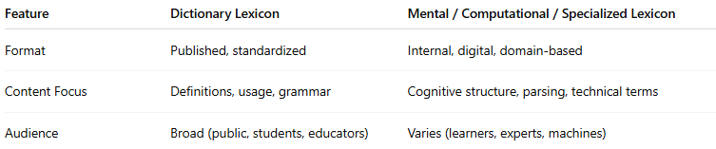
Feature | Dictionary Lexicon | Mental / Computational / Specialized Lexicon
Format | Published, standardized | Internal, digital, domain-based
Content Focus | Definitions, usage, grammar | Cognitive structure, parsing, technical terms
Audience | Broad (public, students, educators) | Varies (learners, experts, machines)

🔹 Applications
# Source: AI Source: Provided by: [Data Path: Persons Table -> ID Column: 1, Name_En Column: Motasem Essam] -> From: [Chatgpt (GPT-4-turbo)] on [7/29/2025]
- Language learning and teaching
- Academic writing and editing
- Lexicographic research
- Language standardization
- Translation and interpretation

